Lab 2

Vaibhav Sandhir
210905152

Q1.)
import pandas as pd
from matplotlib import pyplot as plt
import numpy as np

df = pd.read_csv('xyz.csv', header = None)
print(df.head())
columns = ['preg', 'glu', 'bp', 'sft', 'ins', 'bmi', 'dpf', 'age', 'class']
df = pd.read_csv('xyz.csv', names = columns)
print(df.head())
plt.scatter(df['bmi'], df['glu'])
plt.xlabel('bmi')
plt.ylabel('Glucose')
plt.show()
plt.hist(df['age'])
plt.show()
df.boxplot(column = ['age', 'bmi'])
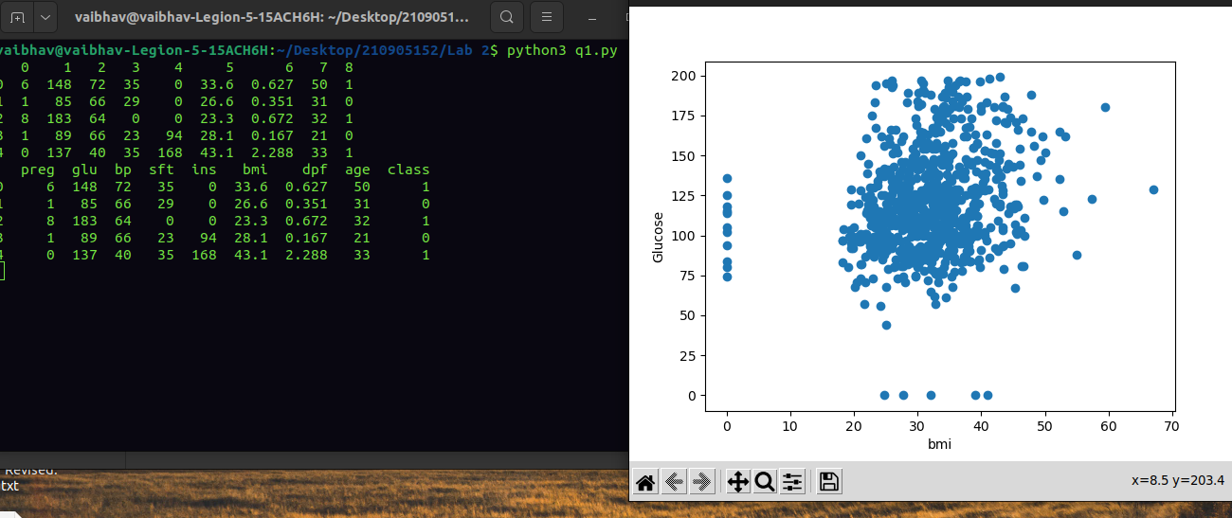

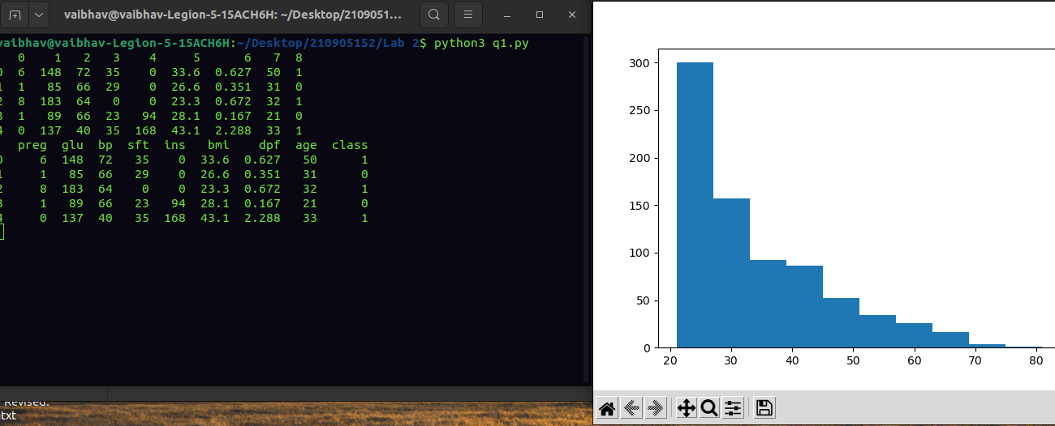
Q2.)
import pandas as pd
from matplotlib import pyplot as plt
import numpy as np

hr = pd.read_table('HR.txt')
print(hr.head())
freq = hr['Department'].value_counts()
print(freq)

freq.plot(kind = 'bar')
freq.plot(kind = 'pie')
cross = pd.crosstab(hr['Gender'], hr['Attrition'])
cross.plot(kind = 'bar')
df1 = pd.DataFrame({'A':pd.Timestamp('20130102'), 'B':np.array([3]*4, dtype = 'int32'), 'C':pd.Categorical(['Male', 'Female', 'Male', 'Female'])})
df1
print(df1.shape)
print(df1.dtypes)
print(df1.T)
print(df1.index)
print(df1.columns)
df11 = df1.sort_index(axis = 1, ascending = False)
print(df11)
df12 = df1.sort_values(by = ['C'])
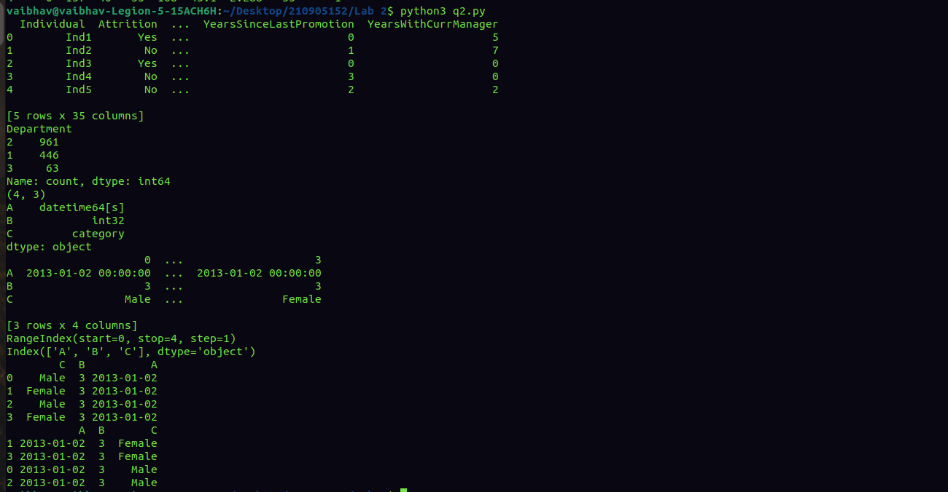
print(df12)

